

Cyber Fundamentals and Internet Safety

Getting Started with Chromebook
This booklet has been verified by the SQA and meets SQA requirements. Any editing of content or questions contained in the booklet by schools needs to be submitted for verification prior to any proposed use.

Introduction to your devices

Now that you are setting up a new device you must be aware of the risks. Your device will be connecting to the Internet which makes it vulnerable to many cyber dependant risks. Today it is estimated that around 50 billion devices are connected to the internet. At the time of writing this booklet it was estimated that the world population is 8 billion people.

Education Scotland has created this risk road map to help you reduce the chances of your devices being infected with malware, as well as recognise, react and recover when you experience issues.
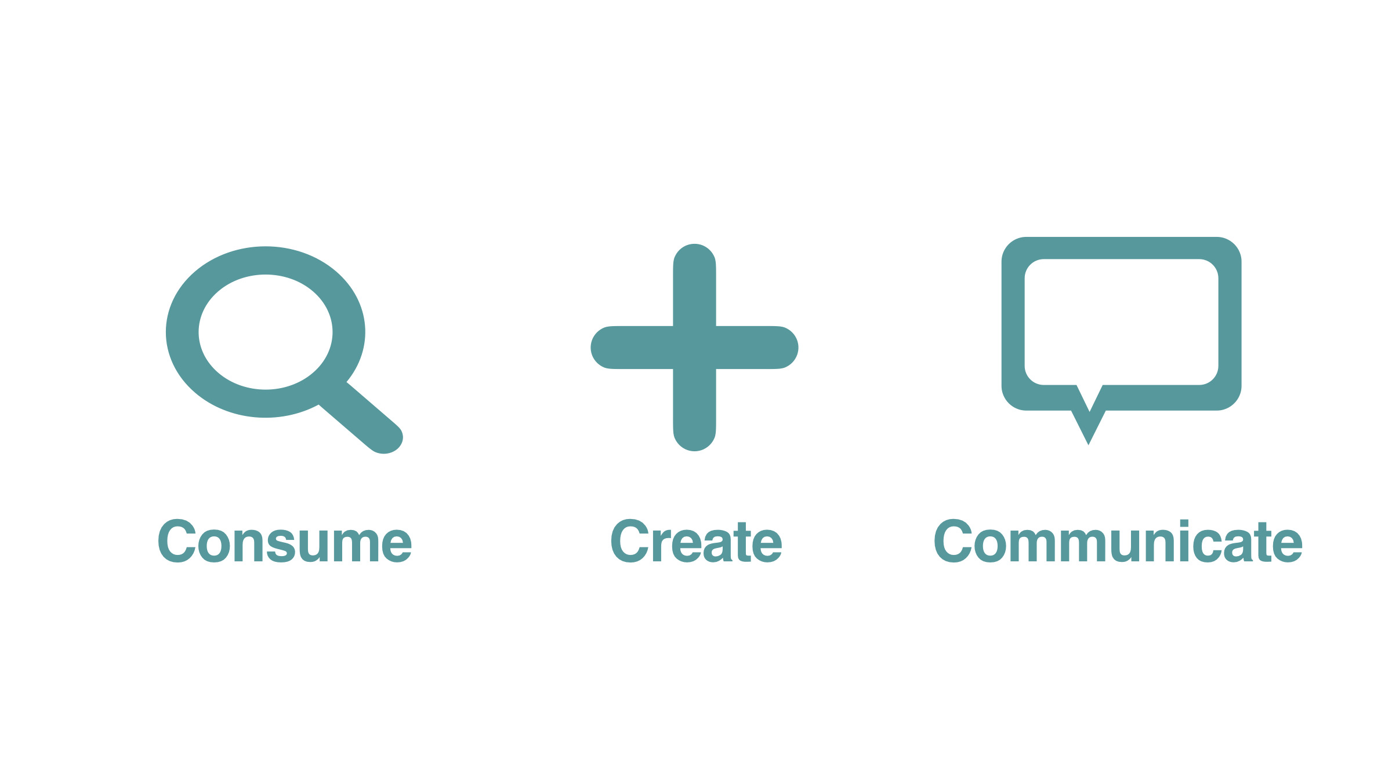

Consume: you will use your new device to view videos, images, play games, download apps and stream movies. We refer to this as consuming content. Using the Internet to consume increases the risk of your device being infected with malware.

Create: once you become more confident with your device you will start to create your own images, videos and games. You will probably create content using apps that you download.

Communicate: Once you have created your own content you will start to share this content with other users on social media apps. We refer to this as communicating content. As you share content between apps and people you increase your risk of passing malware on.

This booklet has been designed to walk you through setting up your device and ensure that you have the skills and knowledge to reduce the risks to your device. If you need any information on the risks of using social media check Booklet 2.

Cyber Security Fundamentals Outcome 1 Performance Criteria a, b, c & d
1. Setting up and reviewing your device:

    - Passcode/figure print/ face recognition
    - OS version/updates
    - Accepting terms and conditions (link to legal stuff)
    - How you connect to Wi-Fi
    - Risks of public (free) Wi-Fi
    - Should you turn Bluetooth on or off
    - Personal hotspots
    - Location service on or off
    - Back up device
    - Set up pay
    - Find my phone/disable device remotely
    - Why you should review device set up as app request access to some features you have turned off
    - Automatic updates

2. Setting up and reviewing accounts:

- Setup email account with appropriate username (if required)
- Identify the important accounts (email) and the account details you are happy to share
- Identify old accounts that may need removed
- Use of appropriate username and passwords
- Recover email and phone numbers attached to accounts such as email when resetting forgotten passwords
- How to recover if an account is hacked – such as a fire escape plan; what will you do if the worst happens: close linked accounts with same email, shut it down, contact platform customer service, restore images from backup device
- How to deal with the consequences when your personal details are stolen (link to LC stuff) and identity theft

Cyber Security Fundamentals Outcome 1 Performance Criteria a, b, c & d
New, new-to-You or shared devices - Chromebooks

When starting a device up for the first time you will be guided through a process to get the device ready for you to use. If it’s a shared device that has already been setup you can still go through the settings to check these measures. The National Cyber Security Centre (NCSC) provides further guidance for buying & selling second-hand devices.

Chromebooks are made by many different manufacturers and will have slightly different setup options. If your device has been provided by a school or local authority it may already be setup and ready for you to use. If not, then you will be asked to:

- Select the language you want the device to use
- Connect to a Wi-Fi source
- Accept the Terms & Conditions
- Sign in with your Google Account – if you already have an account, you will be prompted to import your previous data, such as contacts, photos and apps form your old device to this new one
- If you have previously used an Apple device, this guide will show you how to transfer your account and data over to your new Chromebook
- Set up security features
- Finish setup with updates, apps and payment features – these will depend on the device

Install the latest software and app updates - NCSC.GOV.UK
Tips to stay safe & secure online – Google Safety Centre

Cyber Security Fundamentals Outcome 1 Performance Criteria a, b, c & d
Email - Google Mail (Google Account)
An email is required when setting up a new device or online account, such as shopping or social media. If your device has been provided by your school or local authority you may be able to login with your Glow email and password. However, if you are unable to use a Glow email then Google will provide you with an email service (Google Account) for your Chromebook. You must be 13 years or older to sign up for email.

Email for under-13s: Information for Parents and Carers
It is recommended that children have their own email account, linked to yours. Allowing your child to use your account information increases the risk to your accounts being compromised. Google use the family link app to enable you to create a Google account for a child under the age of 13.

Good practice
It is recommended you have more than one email address for improved security. One for important accounts and services, such as your device account, bank or applications to work, study or training. The second account should be used for online platforms and services that you may use more often, but have less financial risk to you, such as social media accounts, shopping or special offers from your favourite fast-food restaurant

If you already use email, you should check and update your security and safety settings as good practice. Check if your account or password have been compromised at Have I Been Pwned?

Choosing an email address
All email addresses are unique. To create an email account, you will need to think of a username to identity you at the start of your email address. It is recommended that you use your first name and surname as this will be easy to remember, make sense when someone reads it and makes you sound sensible (jobs, training and education applications!).

So, your email address might be:

johnsmith@gmail.com

If your preferred email address has already been registered, Google Account will make suggestions based on your name with a series of numbers to make it unique. If the suggestions are not suitable, hard to remember or you just don’t like them, then you may want to try usernames with dots between first and second name or memorable numbers, such as a year, at the end of your username.

For example: john.smith21@gmail.com

Cyber Security Fundamentals Outcome 1 Performance Criteria e & f

It might be useful to write down the email address at first until you have it memorised. Once you have set up your phone you could then add the email address into the Notes app on your phone, that way it is easy to find when you are asked for your email address.

Google Account account recovery
Google Account will ask you to share another email address or phone number that can be used to send you a password recovery email if you forget your password.
Cyber Security Fundamentals Outcome 1 Performance Criteria e & f
Email Quiz

What two options can you use to reset your password or if you forget your username?

Google Account will ask you to share another email address or phone number that can be used to send you a password recovery email if you forget your password.

Explain why it is good practice to have more than one email address:

It is recommended you have more than one email address for improved security. One for important accounts and services, such as your device account, bank or applications to work, study or training. The second account should be used for online platforms and services that you may use more often, but have less financial risk to you, such as social media accounts, shopping or special offers from your favourite fast-food restaurant

Explain the two methods of creating email accounts for under 13s:

It is recommended that children have their own email account, linked to yours. Allowing your child to use your account information increases the risk to your accounts being compromised. Google use the family link app to enable you to create a Google account for a child under the age of 13.

Do all email addresses have to be unique? (circle/delete as appropriate)

Yes No

Give an example of a sensible email address, suitable for work, training or learning:

johnsmith@gmail.com

Cyber Security Fundamentals Outcome 1 Performance Criteria d, e, f & g
Email Risks

Phishing is probably the greatest risk to email users and because billions of people use email it is often targeted by scammers and criminals for financial gain. Phishing emails try to trick users to click on links to not-to-be-trusted websites or attachments, or to give sensitive information away (such as bank details or games and shopping accounts – banks, games platforms and shopping services that you use, such as PlayStation, Xbox or Amazon, will already know your account details and will never ask for these in an email). If you need to check, call them directly – get their number from your card or their website – do not click any links on the potentially phishing email!

Recognise

It is becoming increasingly challenging to recognise well-constructed phishing scams, but you should always ask yourself:
- Do I use this service?
- Do I know this person?
- Should I be expecting an email from them?
- Look at the sender's name and email address. Does it appear legitimate, or is it trying to copy someone you know?

The scammer will try different techniques to get you to believe them, such as:
- Not referring to you by name – phishing is done on a huge scale and emails will probably not be personalised. A term of familiarity, such as 'valued customer', or 'friend' or 'colleague' will be used
- Fear – scammers may pretend to be the manager or executive of a firm, or an authority such as HMRC, parking fines or the police
- Time constraint – limited time offers or urgency to pay for a service or fine may be used to pressure you into paying before it is too late
- Special offers or deals - if it sounds too good to be true, it probably is. It's most unlikely that someone will offer you designer trainers for £10, or codes to access films for free

React

- Do not respond to the email
- Do not click on any links or attachments in the message
- Report suspicious messages if you are suspicious

If you have received an email which you’re not quite sure about, forward it to the Suspicious Email Reporting Service at report@phishing.gov.uk
Suspicious text messages should be forwarded to 7726. This free-of-charge short code enables your provider to investigate the origin of the text and take action if necessary.

By reporting potential scams you will be helping to protect many more people from being a victim of crime. It’s also worth telling friends and family if you do spot a scam so that they are less likely to fall for it.

Internet safety outcome 1 Performance Criteria a & b Cyber Security Fundamentals Outcome 2 Performance Criteria a, b c, d & e

Recover

If you have already responded to a suspicious message, take the following steps:
- If you have received an email on your Glow account you can Report a Glow Concern
- If you have been tricked into providing your banking details, contact your bank and let them know
- If you think your account has already been hacked (you may have received messages sent from your account that you don't recognise, or you may have been locked out of your account), refer to our guidance on recovering a hacked account
- If you received the message on a school Chromebook or tablet, contact your IT department and let them know
- If you opened a link on your computer, or followed instructions to install software, open your antivirus software and run a full scan
- If you have given out your password, you should change the passwords on any of your accounts that use the same password
- If you have lost money, tell your bank and report it as a crime to Police Scotland - by doing this, you will be helping the battle against criminal activity, and in the process prevent others becoming victims of cyber crime

Internet safety outcome 2 Performance Criteria a Cyber Security Fundamentals Outcome 2 Performance Criteria a, b c, d & e
Email risk quiz

Recognise

Name the most common threat to your email account:

Phishing is probably the greatest risk to email users

What is the goal of a phishing email?

billions of people use email it is often targeted by scammers and criminals for financial gain

What are three possible clues that an email is phishing:

- Do I use this service?
- Do I know this person?
- Should I be expecting an email from them?

React

What should you do if you suspect an email is phishing:

- Do not respond to the email
- Do not click on any links or attachments in the message
- Report suspicious messages if you are suspicious

Recover

What steps should you take in case you need to recover from a phishing email that you have lost money too:

- If you have received an email on your Glow account you can Report a Glow Concern
- If you have been tricked into providing your banking details, contact your bank and let them know

- If you think your account has already been hacked (you may have received messages sent from your account that you don't recognise, or you may have been locked out of your account), refer to our guidance on recovering a hacked account
- If you received the message on a school Chromebook or tablet, contact your IT department and let them know
- If you opened a link on your computer, or followed instructions to install software, open your antivirus software and run a full scan
- If you have given out your password, you should change the passwords on any of your accounts that use the same password
- If you have lost money, tell your bank and report it as a crime to Police Scotland - by doing this, you will be helping the battle against criminal activity, and in the process prevent others becoming victims of cyber crime

Internet safety outcome 1 Performance Criteria a & b Outcome 2 performance criteria a Cyber Security Fundamentals Outcome 2 Performance Criteria a, b c, d & f
Passwords

Passwords are used to make sure only you can access your account. You will either have a Glow password already or need to create a password for your new Google Account. The best way to create a strong password is to use three random words, as recommended by the NCSC. Google Account will ask for additional password measures, such as using uppercase, lowercase and numbers.

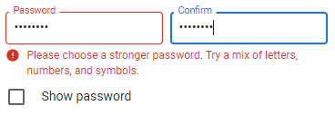

For example: ThreeRandomWords1

Coming up with three truly random words can be challenging. There are online random word generators you can use, but if you don’t have access to the web you can do this at home:

- Take one sheet of A4 paper and cut it into 30 small pieces
- On the first ten pieces of paper write a colour
- On the next ten pieces write a noun
- On the last ten pieces write a verb
- Keeping all the pieces of paper in their groups, fold each piece over
- Now close your eyes and pick one piece of paper from each pile – one colour, one word, one symbol
- Finally, write down your new password – it might look like this:

red giraffe jumped

You can keep the spaces (these count as keyboard characters/symbols) or join the words together. You may also be required to use additional measures that we mentioned above, such as:

Red1giraffe5jumped

Once you have made your new password you can check how secure it is here:
https://howsecureismypassword.net/

Once you have entered your password you are now ready to use your new email account and can use this to set up your new device. You will then be asked for your name, location and date of birth as well.
Cyber Security Fundamentals Outcome 2 Performance Criteria a, b c, & d
Two-factor authentication
In addition to a stronger password most platforms and services will offer additional security features, such as two-factor authentication (2FA) where a code will be sent to your mobile or another email account, or biometric scanning – usually a fingerprint if your device has this option.
Be aware – if you receive a 2FA notification but have not tried to log in to an account then this might be someone trying to hack your account.

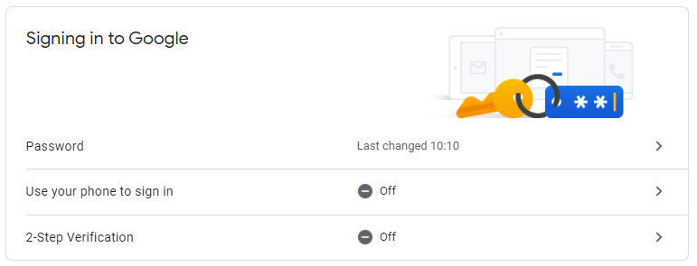

Password Managers
A password manager is an app/software that can create and store all the passwords for your online accounts, so you only need to create and remember one password – for the password manager! However, if someone cracked your password manager – they would have access to all your online accounts.

You may already be using a password manager without knowing it - Internet browsers, such as Google Chrome , have this built in. Check your browser settings more info.

Further guidance on password mangers can be found here:
https://www.ncsc.gov.uk/collection/top-tips-for-staying-secure-online/password-managers

https://www.ncsc.gov.uk/cyberaware/home#section_4

Cyber Security Fundamentals Outcome 2 performance criteria a Outcome 3 Performance Criteria a & b
Password quiz

What is the NCSC’s advice on making a secure password?

The best way to create a strong password is to use three random words, as recommended by the NCSC.

What are two methods that can be used to generate your random words?

There are online random word generators you can use, but if you don’t have access to the web you can do this at home:

- Take one sheet of A4 paper and cut it into 30 small pieces
- On the first ten pieces of paper write a colour
- On the next ten pieces write a noun
- On the last ten pieces write a verb
- Keeping all the pieces of paper in their groups, fold each piece over
- Now close your eyes and pick one piece of paper from each pile – one colour, one word, one symbol
- Finally, write down your new password

Name two additional security features that you can use with, or instead of, passwords:

Two-factor authentication
Password Managers

Use howsecureismypassword.net to test how secure your password is. Write down the number of years it would take to crack your password:

1 thousand years

Does your password include numbers and special characters, such as punctuation or spaces? (circle/delete as appropriate)
Yes No

Does your email provider allow 2FA? (circle/delete as appropriate)

Yes No

Cyber Security Fundamentals Outcome 2 performance criteria a, b Outcome 3 Performance Criteria a & b
Is 2FA turned on for your account? (circle/delete as appropriate)

Yes No

If 2FA is not turned on, how do you reset your password?

Phone number
another email
security questions

How would you rate your email security? (circle/delete as appropriate)

Very Secure Quite Secure Not Secure

How could you improve your email security?

Cyber Security Fundamentals Outcome 2 performance criteria a, b Outcome 3 Performance Criteria a & b

Understanding your Chromebook’s Security
Now that you have an email account that is secure you can complete the setup of your new device. This section will provide information to help you understand the risks to your device. The most obvious risk to your device is someone gaining access to it without your permission – a passcode or password will prevent someone physically doing this. However, it is possible someone may try to access your device remotely via the Internet. This section will guide you through the rest of your device’s setup and the risks to consider before you start to use it.

Connecting to Wi-Fi
Your device will have two methods of connecting to the Internet, either using Wi-Fi or mobile data provided by a company such as Vodaphone. If you are using a company to access the Internet you will need a SIM card – these can be placed in your phone, tablet or Wi-Fi hotspot. To connect to Wi-Fi, you must make sure Wi-Fi is turned on in your Chromebook settings. You should see the Wi-Fi icon on your device if Wi-Fi is turned on.

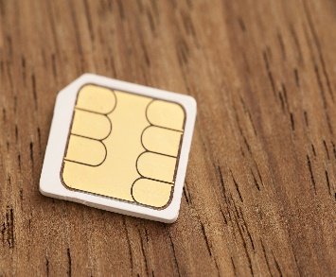 | 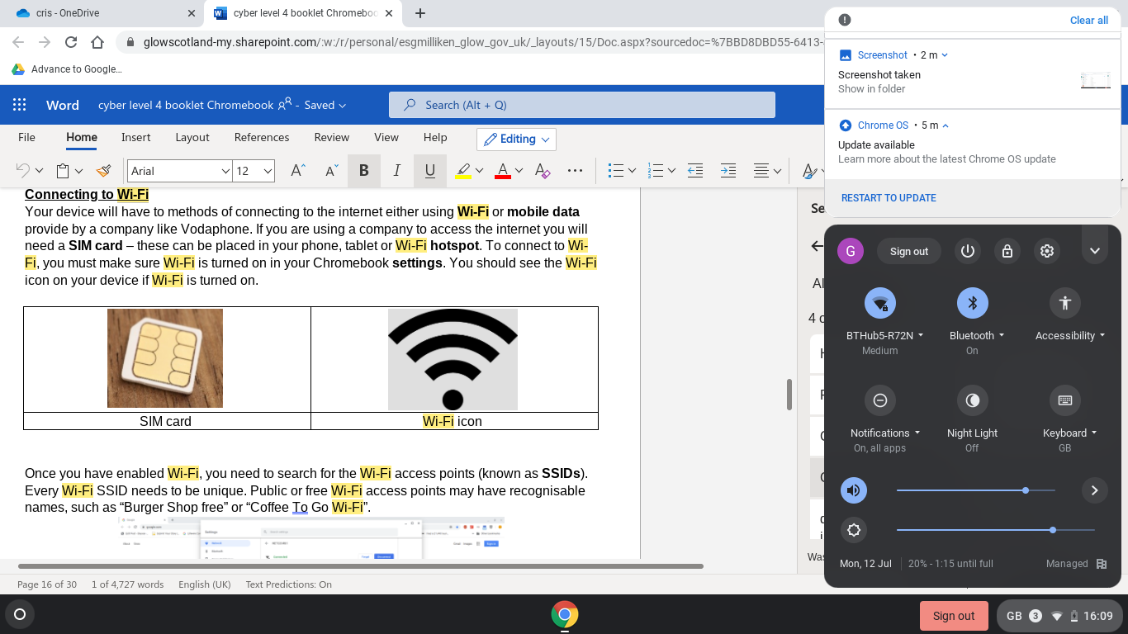
SIM card | Wi-Fi icon

Once you have enabled Wi-Fi, you need to search for the Wi-Fi access points (known as SSIDs). Every Wi-Fi SSID needs to be unique. Public or free Wi-Fi access points may have recognisable names, such as “Burger Shop free” or “Coffee To Go Wi-Fi”.
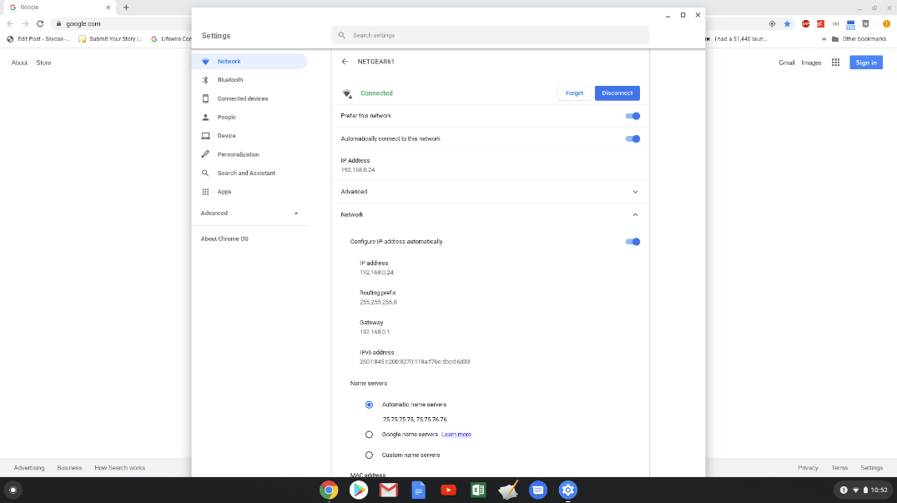

Cyber Security Fundamentals Outcome 3 Performance Criteria a, b & c
Risks of using Wi-Fi in public spaces
Wi-Fi is generally unsecured by the organisation offering it but at the same time it is difficult for hackers to access your device remotely using Wi-Fi. The biggest issue to be aware of is any public Wi-Fi that requires you to register and sign in – this may be an attempt to capture your personal details and password that you use on other accounts. Most public Wi-Fi hotspots will either be open or require a publicly displayed password. To be safe, use free Wi-Fi as little as possible on your mobile device. Never use it to access confidential or personal services, such as banking or shopping.

You can reduce the risk by:
- Checking the name of the SSID is the correct one
- Turning off Wi-Fi when not in use so that it does not automatically connect to Wi-Fi (this also saves a huge amount of battery power too!)
- Removing any old or unused Wi-Fi SSIDs from your device’s Wi-Fi list

Another, more obvious, risk to your device is someone connecting to your Wi-Fi or hotspot and using your data without your knowledge.

Personal hotspots
A MiFi dongle or mobile device with a SIM card can be used to create a personal Wi-Fi hotspot – this turns the device into a Wi-Fi provider so that other nearby devices can connect to the Internet using its data. If you create a hotspot then you can share the SSID and login details for others to access and use your data. However, always be aware of who is connecting to your network – ideally this should only be friends and family that you trust.

Location settings – device
Your device will automatically be setup to track your location. Location settings are enabled to allow web services, such as search engines and maps to know where you are and provide more accurate and relevant information. Most services and apps will also have their own location settings – turning off the app location settings will usually not impact the device’s settings and vice versa.

BE AWARE that turning off location services will disable apps, such as Find My Device that can be used to track and disable your device if it is lost or stolen.

Chromebook Security
Your Chromebook will use your Google Account username and password as your device security, requiring this to login to your device.

Some devices will also use biometrics, such as your face or fingerprint to allow you to login. Biometrics are widely recognised as the most secure methods available on mobile devices.

Cyber Security Fundamentals Outcome 1 Performance Criteria a & b
- Chromebook quiz
Recognise

What are the risks of using public Wi-Fi?

Explain what a hotspot is:

What are location settings used for?

React

What steps can you take to make sure the Wi-Fi is trustworthy?

What should you do when you are finished using a public Wi-Fi?

Recover

If your device was lost or stolen, how could you recover it?

Cyber Security Fundamentals Outcome 1 Performance Criteria a & b
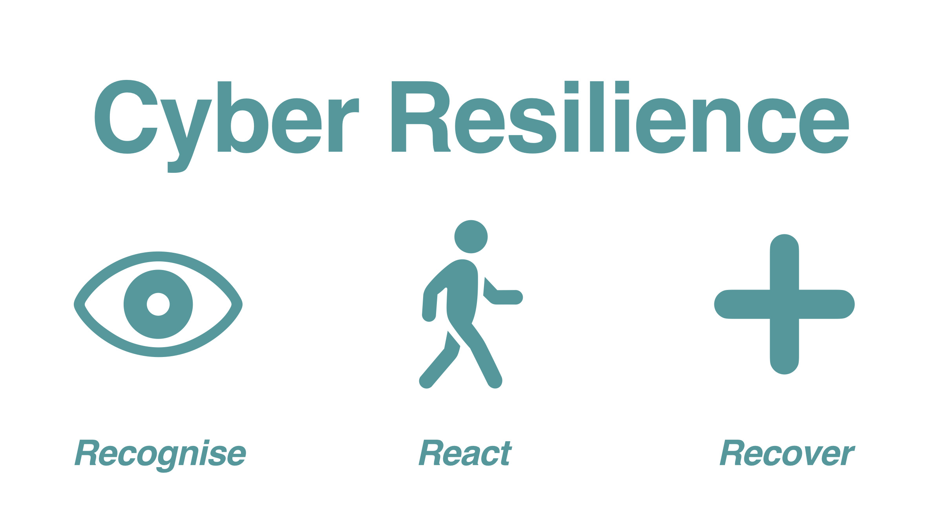

Online Risks to Your Device
In the previous section you set up security features that kept your device physically secure. However, once you connect to the Internet there are remote risks to your device security. These risks will vary depending on how you use your device and whether you consume content, create content or communicate with others. The more you create and communicate content the bigger your digital footprint and the more ‘visible’ you become online and therefore the more likely you and your device are to be attacked.
It is illegal to knowingly distribute malicious software under the Computer Misuse Act (UK).

Being Cyber Resilient – living with online threats and risks
Our cyber resilience strategy for online threats is simple:
- Recognise - know the threats you might face and be aware of where they come from (emails, websites, direct messages)
- React – know what to do when you are attacked or threatened with malware
- Recover – have a plan to help you recover accounts, details, photos etc. that you may lose in an attack

Cyber Security Fundamentals Outcome 1 Performance Criteria a, b & c outcome 2 d
Recognise
When you are using your device, the biggest risk is that you infect your device with malware- malicious software, which - if able to run - can cause harm in many ways, including:
- Causing a device to become locked or unusable
- Stealing, deleting or encrypting data
- Taking control of your devices to attack other organisations
- Obtaining credentials which allow access to your other accounts or platforms
- 'Mining' cryptocurrency
- Using services that may cost you money (e.g. premium rate phone calls)

These are some examples of malware you should be aware of:
- Viruses
- Spyware
- Ransomware
- Trojan horses
- Adware
- Worms
- Botnets

Some malware, such as viruses and ransomware, will usually inform you that they have infected your device, while others will work in the background without alerting you, such as botnet attacks, adware or trojans.

Cyber Security Fundamentals Outcome 1 Performance Criteria a, b & c outcome 2 d
Ransomware
Ransomware is the single biggest threat to individuals - it is a type of malware that prevents you from accessing your device (or the data that is stored on it). The device itself may become locked, or the data on it might be stolen, deleted or encrypted. Usually, you are asked to contact the attacker via an anonymous email address or follow instructions on an anonymous web page, to make payment. However, even if you pay the ransom, there is no guarantee that you will get access to your device, or your files. For these reasons, it's essential that you always have a recent offline backup of your most important files and data.
If your device is infected with ransomware you may see the following on your screen:
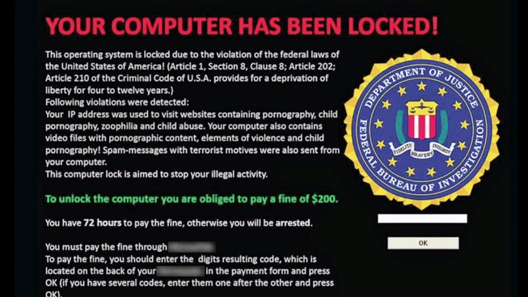 | 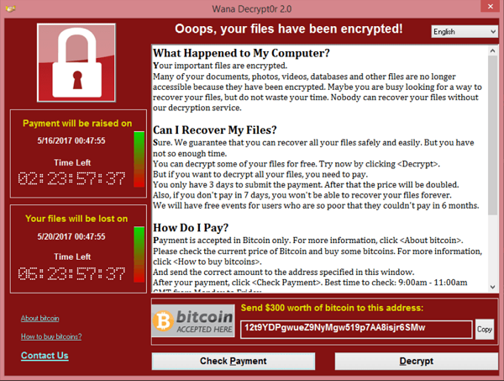

RANSOMWARE CAN’T ENCRYPT YOUR DEVICE WITHOUT YOU
You need to click the link or file for it to encrypt your data

Cyber Security Fundamentals Outcome 1 Performance Criteria a, b & c outcome 2 d
Online Risks Quiz part 1

Recognise

What is the main reason malware is used by criminals?

Has cybercrime been increasing or decreasing over the past 5 years?
(circle/delete as appropriate)
increasing or decreasing

Explain a reason for your choice?

What are the three Rs of cyber resilience?

State the name of the most common malware attacked used against you.

Explain the reason why the attack stated above is so successful?

Explain what the impact on your device will be if infected with malware

Which piece of legislation states that it is illegal to intentionally harm someone’s device?

Cyber Security Fundamentals Outcome 1 Performance Criteria a, b & c outcome 2 d

React
You can only get malware on your device by doing one of the following:
- Downloading/installing apps
- Clicking on links
- E-mail
- Using unsecure Wi-Fi

By being aware of current threats and scams you have a better chance of spotting them when they try to infect your device. Remember that malware is a computer program (like an app) that needs you to activate it. You can reduce the risk of malware infecting your device by:

- Only downloading apps from trusted apps stores, such as the Apple App Store or Google Play Store
- Reading app reviews in the store - if the app is not legitimate or trustworthy people will often write critical reviews
- Checking URLs before clicking them – are they secure (https: and not http)
- Scrutinising the email subject, sender and content - is it from someone you would expect to be emailing you? Are the graphics logos accurate and high quality? Poor grammar and spelling is also a common feature of phishing emails.
- Double-checking the Wi-Fi SSID you are connecting to and turning off Wi-Fi when not in use

Ideally, by recognising threats to your device and reacting to stop them attacking or infecting it you can avoid most threats. However, if your device is infected with malware then you can run anti-virus software – if this is up-to-date it may be able to identify and remove the infected file(s). Anti-virus is only as good as the latest update and new malware is being created all the time.

If your device has been affected by ransomware the NCSC recommends you do not pay the ransom to unlock it as there is no guarantee it will be unlocked and this only encourages more attacks. The No More Ransom website offers ransomware unlock keys which might be able to unlock and recover your device. However, you may not be able to recover your device in which case you will need a recovery plan.

Cyber Security Fundamentals Outcome 1 Performance Criteria e outcome 2 performance criteria c
Recover
This is the most important step and because of the proliferation of cyber-crime it is better to prepare for, rather than to only try and prevent, an attack. If you haven’t planned to recover, the chances are you will lose your data in a cyber-attack. In the unfortunate event that your device does become infected with malware you should be prepared to perform a factory reset (losing all the data on it) or even buying a new device.

How to recover an infected device - NCSC.GOV.UK

Recovering a hacked account - NCSC.GOV.UK - other book

If it’s not possible to remove the malware from your Chromebook then it is important that you have made a backup of the data stored on your device. Google Account (15GB) will provide limited free storage and regularly back your data up to their cloud service (paid-for upgrades are available to store more data). This is automatically enabled when you set your device up.

Backup strategies
Modern devices will back up your device’s storage using cloud servers – this means that instead of only storing the data on your device it will also make a copy on Google’s network too. This means that it can be accessed at any time and on any device that you log in to – making it easy to restore data, even from an old device to a new one if required.

When storing your data on a cloud platform, you may need to consider how much you can actually back up – 1GB can hold hundreds of images and lots of videos but this will depend on the size of the files (quality of images, and quality and length of videos) - so you may need to decide on which pictures to keep and which to delete each time you backup your most important data.

Cyber Security Fundamentals Outcome 1 Performance Criteria e outcome 2 performance criteria c
Online Risks Quiz part 2

React

What should you do if you get ransomware on your device?

What is the name of the software needed to remove malware from your device?

Recover

How does your Chromebook help you prepare for recovery of your data?

What makes cloud storage useful for cyber recovery?

How often are backups made of the Chromebook

Do you back your data onto a cloud or a hard drive? (circle/delete as appropriate)

cloud or a hard drive

Cyber Security Fundamentals Outcome 1 Performance Criteria e outcome 2 performance criteria c

Education Scotland
Denholm House
Almondvale Business Park
Almondvale Way
Livingston EH54 6GA

T +44 (0)131 244 4330
E enquiries@educationscotland.gsi.gov.uk

www.education.gov.scot


